|  |  |  |
| --- | --- | --- |
| Eruption of Primary Teeth | | |
| **6 – 36 Months** | **6 – 9 Years** | **9 – 12 Years** |
| * Anterior teeth erupt in vertical upright position – **less overjet**. * Deep bite – **Increased overbite** * Dentition can be either:   + Spaced Dentition (physiological/ development spaces).     - **Primate Spaces** can be seen mesial to upper canine and distal to lower canine.   + Closed * **Terminal Plane** – according to distal of upper- and lower-second molars. Can be: | * Early mesial shift occurs in spaced dentition where posterior teeth **shift mesially** to fill the primate spaces.  Closed dentition lacks primate spaces, so **no mesial shift** happens. * **Incisor Liability**:  Primary BA 🡪 AB  MD width = X Permanent 21 🡪 12  MD width = Y Y – X = 6-7mm   + Interdental spacing: 2—3mm   + Intercanine arch growth: 3—4mm   + Incisor Liability: 1—2mm | * **Leeway Space of Nance**: size differential between primary and permanent posterior teeth. * Primary MD Width of EDC > Permanent MD Width of 543   + Maxilla= 0.9mm/1.8mm   + Mandible= 1.7mm/3.4mm   🡺 Width difference will be filled with **Late Mesial Shift**   * **Ugly Duckling Stage (Broadbent Phenomenon 9—11 years) –** flaring of the upper central and lateral incisors |

**Serial Extraction**

|  |  |  |  |  |
| --- | --- | --- | --- | --- |
|  |  |  |  |  |
|  | Extract primary canines to allow eruption and optimal alignment of lateral incisors | Extract primary 1st molar to accelerate eruption of 1st premolar ahead of permanent canines if possible | Extract permanent 1st premolar to allow the erupting canine to drift distally into premolar space | Outcome: 1. Aligned Incisors 2. Missing first premolar 3. Spacing in posterior segment 4. Canine occupying space of 1st premolar |

**Habit Breaking Appliances**

* **Tongue Thrusting**

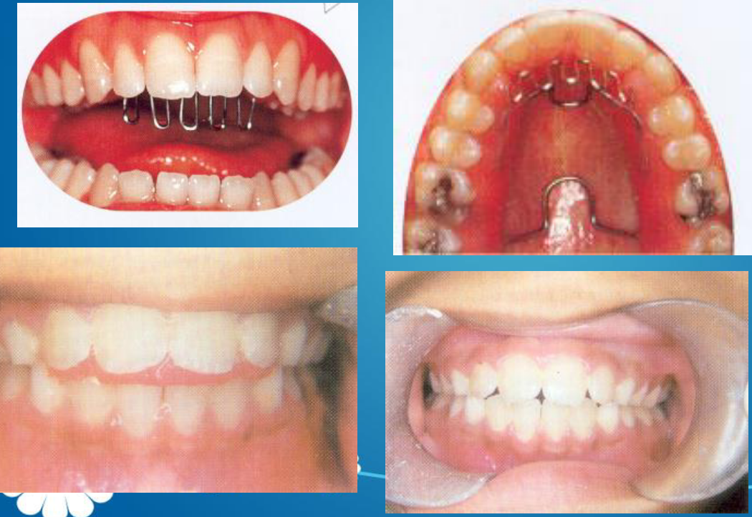

* **Digit Sucking – Blue Grass Appliance**

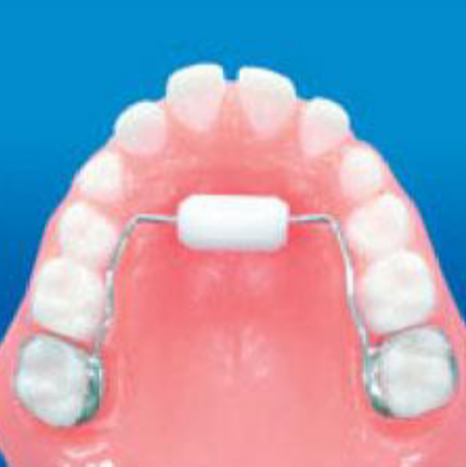

* **Mouth Breathing**:
  + - Etiology:
      * Deviated nasal septum
      * Allergic Rhinitis, Nasal polyps
      * Enlarged adenoids or tonsils
      * Short upper lip preventing lip seal
      * Obstruction in bronchial tree
    - Appliance: **Oral Screen**

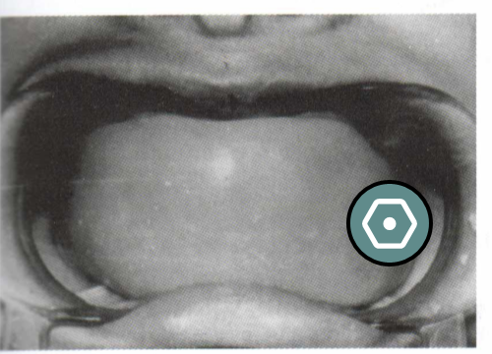

* **Incorrect alignment of dentition due to pressure from the soft tissue**

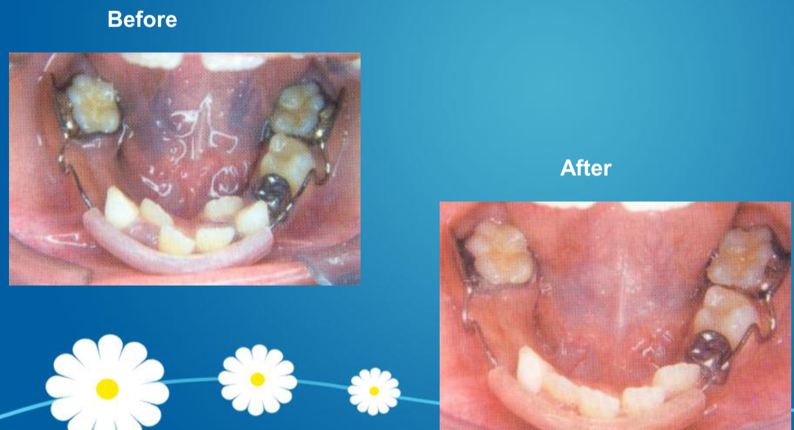

* **Anterior Crossbite**
  + - Corrections:
      * Tongue Blade Therapy

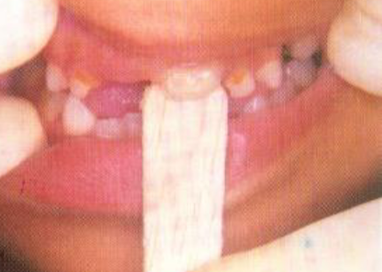

* + - * Lower inclined plane (catalan’s appliance)

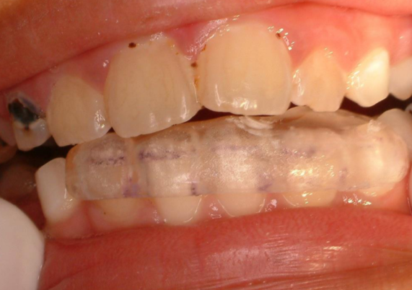

* + - * Removable Hawley’s appliance
      * Fixed appliances
* **Posterior Crossbite**
  + - Space supervision
    - Space maintainer
      * Single unilateral posterior space maintainer

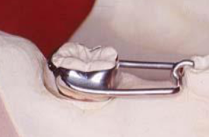

* + - * Distal shoe space maintainer

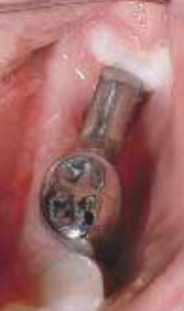

* + - * Bilateral Loss – Lower
        + Lower lingual holding arch

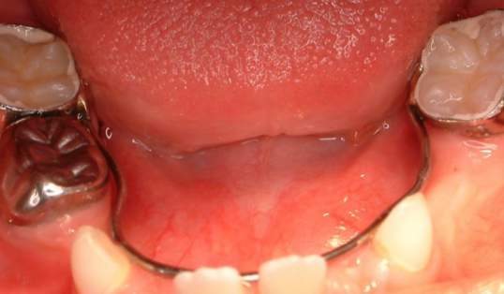

* + - * Bilateral Loss – Upper
        + Transpalatal Arch (Bar)

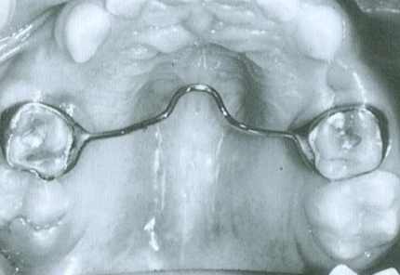

* + - * + Nance Appliance

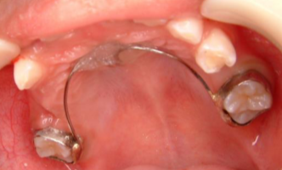

* + - * Fixed Space maintainer for Anterior Teeth

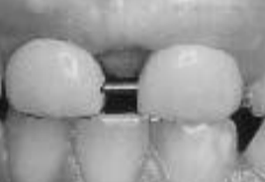

* + - * Bonded space maintainer

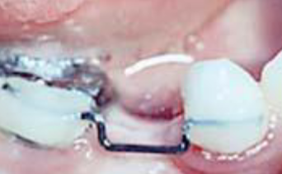

* + - * Preformed space maintainer

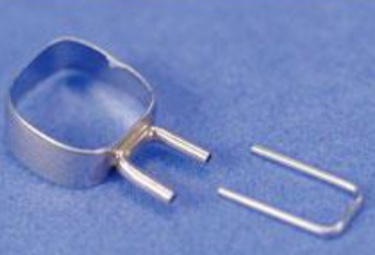

* + - Fixed space re-gainer
      * Lip bumber